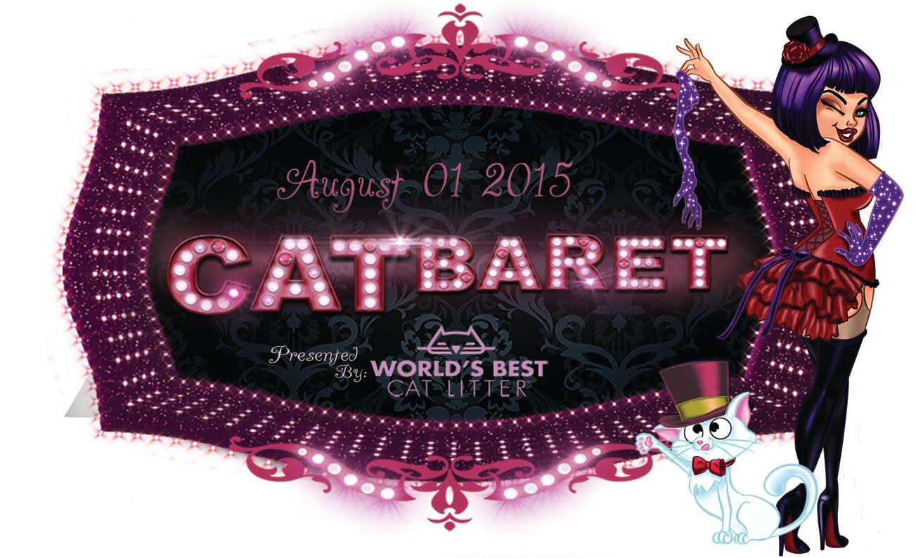
A-List Celebs & the Coolest Cats Around! Kitty Bungalow’s Star-Studded CATbaret Promises Night to Howl About
Benefit Concert Sponsored by World’s Best Cat Litter at the Avalon Theater in Los Angeles

Los Angeles, CA – August 1, 2015 – Cats may get 9 lives, but the biggest night of the year may feel more like a once-in-a-lifetime event. On August 1st, feral cat rescue group, Kitty Bungalow Charm School for Wayward Cats, will host its 5th annual star-studded benefit concert, CATbaret, at the historic Avalon Theatre in Hollywood.
The one-night only mewsical will raise proceeds for Kitty Bungalow, the only cat rescue in Los Angeles that focuses entirely on street cats, providing free spay neuters for feral cats while offering a lifeline to homeless kittens born on the streets.

The evening, which is sure to have cats and people purring alike, will feature stars of stage and
screen performing popular cat-themed songs including Stray Cat Strut, Black Cat Bone, Year of
the Cat Jellicle Ball and more, all accompanied by a live band.

This year sing and dancing in the name of the cat include the legendary This year sing and dancing
in the name of the cat include the legendary Fred Willard; Wendi Mclendon-Covey (The Goldbergs),
Elaine Hendrix (Sex&Drugs&Rock&Roll), Jaime Ray Newman (Mind Games), Autumn Reeser (The OC),
Keith David (Community), Mo Collins (Parks and Rec), Lori Alan (Sponge Bob), Fred Stoller (Austin
Powers), Elisabeth Harnois (CSI), Jon Huertas (Castle), Nia Peeples (Pretty Little Liars), Scot Robinson
(Anchorman), Kate Flannery (The Office) Katie Cleary (Shelter Me), choreographers Tabitha and
Napoleon, Doriana Sanchez and the So You Think You Can Dance dancers and more! and many more!
So You Think You Can Dance dancers will once again glide across the stage and enchant the audience with their cat-like grace in choreography by celebrity choreographers Tabitha and Napoleon, Benji Schwimmer and Dorian Sanchez!

After the show, guests can enjoy up close and personal moments with the celebrity cast at the VIP celebrity after-party. 100% of all sales go to help rescue more homeless animals, thanks to the generous support of our sponsors: World’s Best Cat Litter, By Nature, Nature’s Variety, Pioneer Pet, Bayer Animal Health and Found Animals Foundation.

CATbaret is a joyous way to raise awareness and funds so Kitty Bungalow can continue its mission of ending the proliferation of homeless cats.

About Kitty Bungalow
Kitty Bungalow Charm School for Wayward Cats is a 501c3 nonprofit organization that rescues, neuters, socializes and find homes for feral kittens while providing outreach, education and Trap-Neuter-Release (TNR) services. Dedicated to the city of Los Angeles and its street cats, their goal is a truly humane LA.
Contact: Henry Eshelman – heshelman@platformgrp.com

